**A TECHNICAL REPORT ON CSIR-FRI CUSTOMER SERVICE WORKSHOP**

**HELD ON THE 27TH OF FEBRUARY, 2025 AT CSIR-FRI CONFERNCE ROOM**

**SUBMITTED BY**: **T. Najah,** R. G. Tsiquaye, N.O-Appiah G. Appiagyei, E. Ofori, J.B. Dzikunu,, R. Nyanmpong, R. Atiemoh, E. Nkrumah.

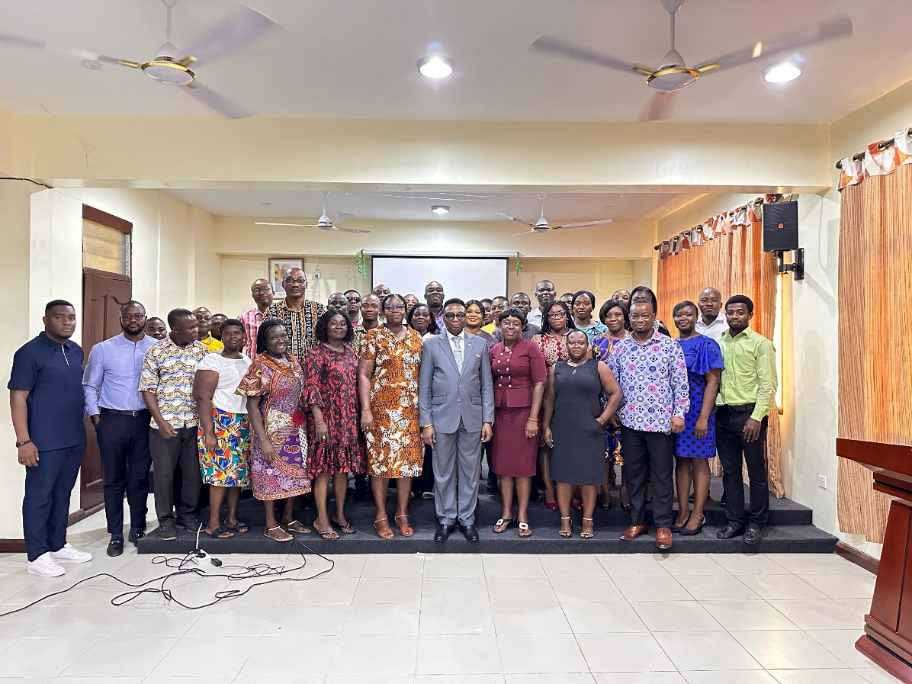

**Table of contents**

**1.0** **Introduction** 3

**Fig 1.0: The Director, Prof. Charles Tortoe is giving the opening remark………………….3**

Table 2.0: Head/Commercialization, Mr. Thomas Najah delivering a speech 4

**2.0 Good Customer Service Practices** 5

Fig 2.0: An address by the Director of Commercialization, CSIR 5

**2.1 Relation Marketing Strategies** 6

**2.2 Artificial Intelligence in sales & Marketing: Enhancing Customer Satisfaction, Experience and Loyalty** 7

Fig 4.0: Mr. Ebenezer Nkrumah engaged Participants on the using AI in sales 7

**2.3 Customer Service & the Business Model Canvass: Role of Marketing** 8

Fig 5.0: Mr. Reginald Atiemoh, waiting for his lecture 8

Fig 6.0: Participants in attentive mood 9

**2.4 Interaction Stage** 9

**3.0 Closing Remarks** 10

# **Introduction**

Customer service, refers to the assistance an organization offers to its customers before or after they buy or use products or services. Customer service includes actions such as offering product suggestions, troubleshooting issues and complaints, or responding to general questions (Kotler, 2015).

On 27th of February, the head of the Commercialization Division with the permission by the CSIR-FRI management, organized a Customer Service Workshop held at the CSIR-FRI Conference room. In all, 68 participant attended (**Appendix 1A**). Among some of the dignitaries present were, the Director of the Institute, Prof. Charles Tortoe, the Director of Commercialization of CSIR, Mrs. Naomi owusu-Appiah, the deputy Director of the Institute, Dr. Gregory Komlaga among others

This was a significant step toward its customer service delivery, particularly in commercialization.

This workshop even though was organized by the head of commercialization, Mr. Thomas Najah for his divisional staff, it brought together key staff, including front desk, Marketing, public Relation, and the research Scientists.

The main objective of this workshop was to equip participants with skills needed to provide world-class customer service, ultimately driving satisfaction and loyalty.

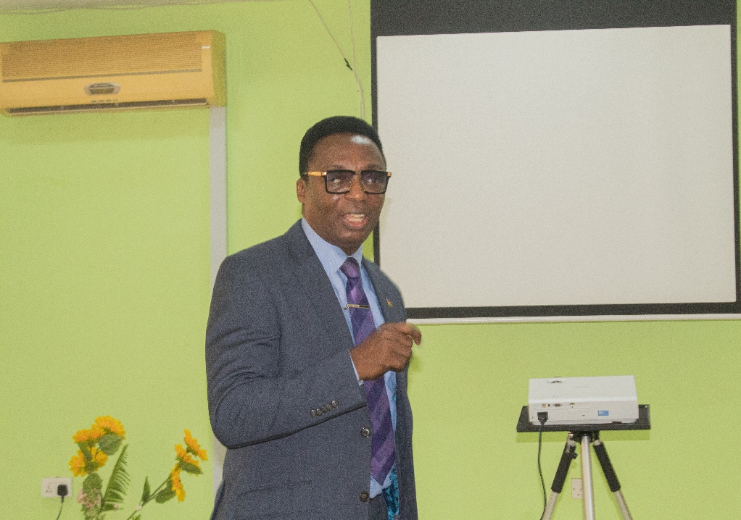

**Fig 1.0: The Director, Prof. Charles Tortoe is giving the opening remarks**

The Director of the Institute Prof. Charles Tortoe in his speech said the workshop was aimed at empowering staff with top-notch customer service skills, emphasizing customer engagement and satisfaction as crucial elements. In today’s competitive market, exceptional customer service is vital for organizational success. By prioritizing customer needs and adapting to emerging trends in service delivery, Prof. Tortoe reiterated that CSIR seeks to maintain its competitive edge and promote Made-in-Ghana goods.



# **Table 2.0: Head/Commercialization, Mr. Thomas Najah delivering a speech**

The head of commercialization Division at CSIR-Food Research Institute, Mr. Thomas Najah, outlined the workshop’s primary goal as achieving customers’ happiness. Citing the Marketing Mix Concept, he emphasized the importance of ‘People’-specifically, understandings and catering to customer needs. “A company’s success hinges on its customers.” He noted, highlighting that a company that providing the right products to customers is crucial for satisfaction and profitability. And to do that, a company has to identify the right people from within to identify the right people in the market for the company to deliver the right product. He concluded.

There were four presentations in all.

* Good Customer Service Practices
* Relationship Marketing Strategies
* Customer Service & the Business Model Canvass: Role of Marketing
* Artificial Intelligence in sales & Marketing: Enhancing Customer Satisfaction, Experience and Loyalty.

# **Good Customer Service Practices**

CSIR has consistently demonstrated its commitment to customer-centricity and staff development through numerous workshops and training programs. By enhancing customer satisfaction, loyalty, and retention, ultimately driving business growth and sustainability.



# **Fig 2.0: An address by the Director of Commercialization, CSIR**

According to the Director of Commercialization at CSIR, Mrs. Naomi Owusu-Appiah, understanding the commercialization mandate and its reliance on customer satisfaction is crucial. She emphasized that effective customer service involves positive interactions before, during, and after a purchase or service. She noted that key principles and best practices in service delivery drive customer acquisition, loyalty, and retention.

This initiative also supports Ghana’s economic development goals by promoting local industries and products. By investing in staff development customer service, CSIR, is taking a proactive approach to driving business growth and contributing to the country’s economic development.

# **2.1 Relation Marketing Strategies**

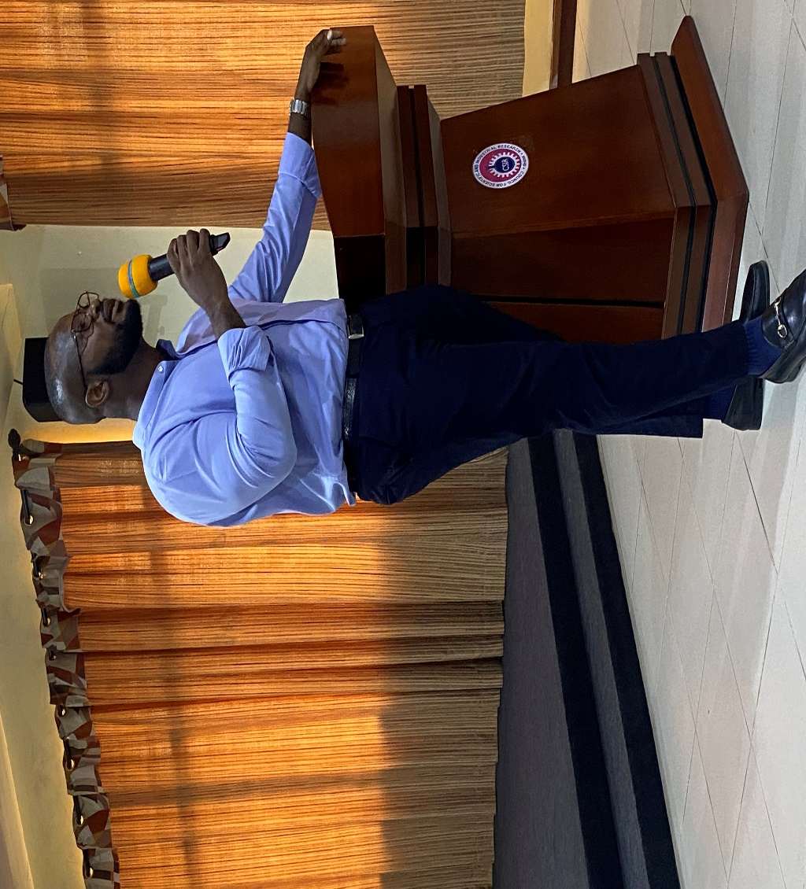

**Fig.3.0: Mr. Atadika given a lecture**

Christian K. Atadika, a PhD. Candidate from the University of Ghana, representing Prof. Kobbie Mensah emphasized the importance of regular training sessions for research institutes, particularly in Marketing and commercial relations. He noted that such sessions enable staff to stay up to date with modern marketing practices, effectively promoting their products and services. Atadika highlighted relationship marketing strategy as a key focus area in driving customer acquisition and retention, ensuring the organization’s sustainability and profitability.

# **2.2 Artificial Intelligence in sales & Marketing: Enhancing Customer Satisfaction, Experience and Loyalty**

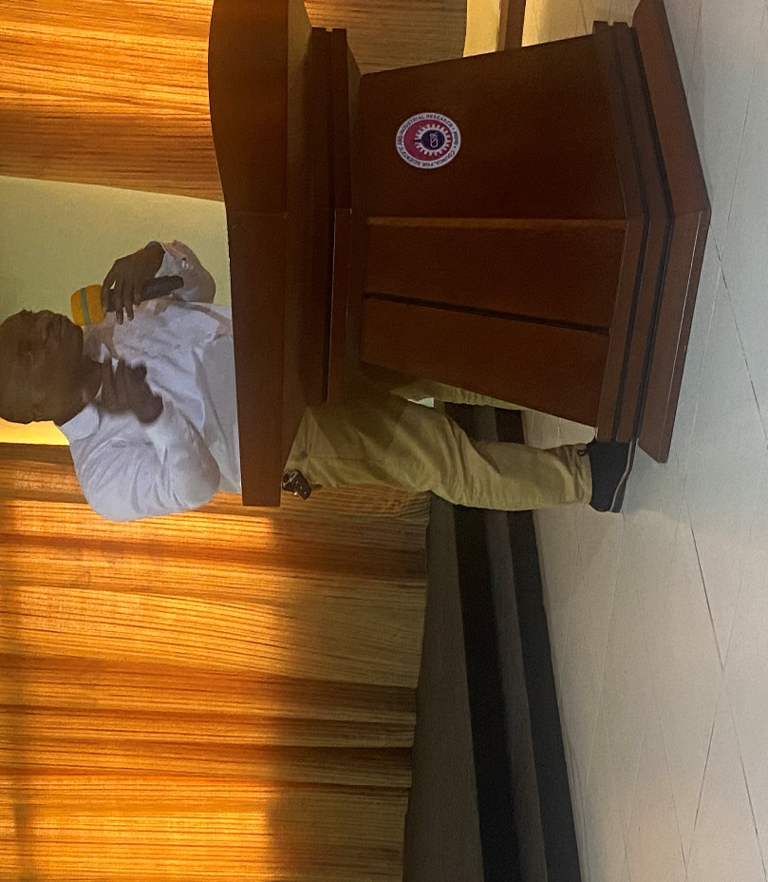

# **Fig 4.0: Mr. Ebenezer Nkrumah engaged Participants on the using AI in sales**

Ebenezer Nkrumah, head of commercialization for CSIR-Water Research Institute, discussed the role of Artificial Intelligence (AI) in enhancing customer satisfaction, experience, and loyalty. He highlighted three key areas where AI plays a crucial role: personalization, automation, and content creation.

AI empowers businesses to customize services, provide in-depth product information, and influence customer decisions. Additionally, AI automation simplifies task, such as email management, enabling businesses to communicate effectively with their audience and build strong customer relations.

# **2.3 Customer Service & the Business Model Canvass: Role of Marketing**



# **Fig 5.0: Mr. Reginald Atiemoh, waiting for his lecture**

Reginald Atiemoh, a Senior Marketing Officer at the CSIR-Institute of Industrial Research presented on Customer Service & Business Model Canvas, emphasizing the importance of targeting the right audience. To remain competitive, CSIR must balance affordability with quality, which can be achieved through efficient resource procurement and production. By collaborating with the CSIR-Crop Research Institute, CSIR can leverage resource such as farm gates, laboratories and other expertise to produce high quality, nutritious, and affordable food.

The ultimate goal is to promote made-in-Ghana goods by offering quality, branded and nutritious options to the local and international markets.

By streamlining processes and reducing costs, CSIR creates a win-win situation for consumers, businesses, and the private sector as a whole. This underscores its commitment to quality service delivery, economic growth, and national development.

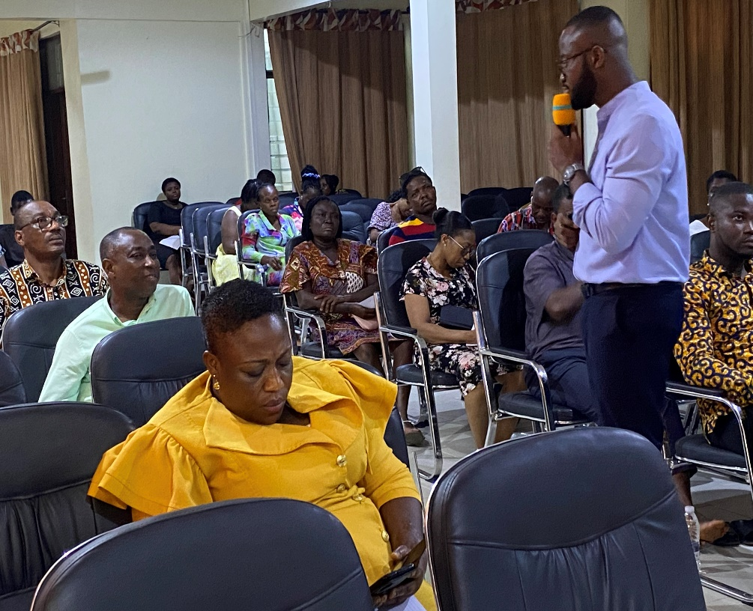

# **Fig 6.0: Participants in attentive mood**

# **2.4 Interaction Stage**

To make the program lovely and interesting, there was an interactive stage where participants asked and answered questions. There were demonstrations on how one could speak to a ruddy and scrupulous customers/clients/consumers/shoppers.

This made the participants to appreciate the importance of the program.

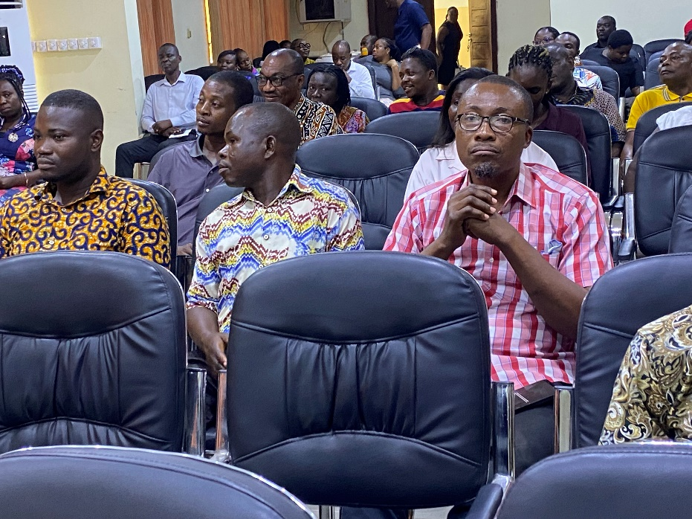

**Fig 7.0: A section of the participants**

# **3.0 Closing Remarks**

Prof. Charles Tortoe in his closing remarks, praise the head of commercialization for pulling this program through. He made a promise that he was going to make it an annual events and tasked the organizers to maintain the status quo.

**Appendix**

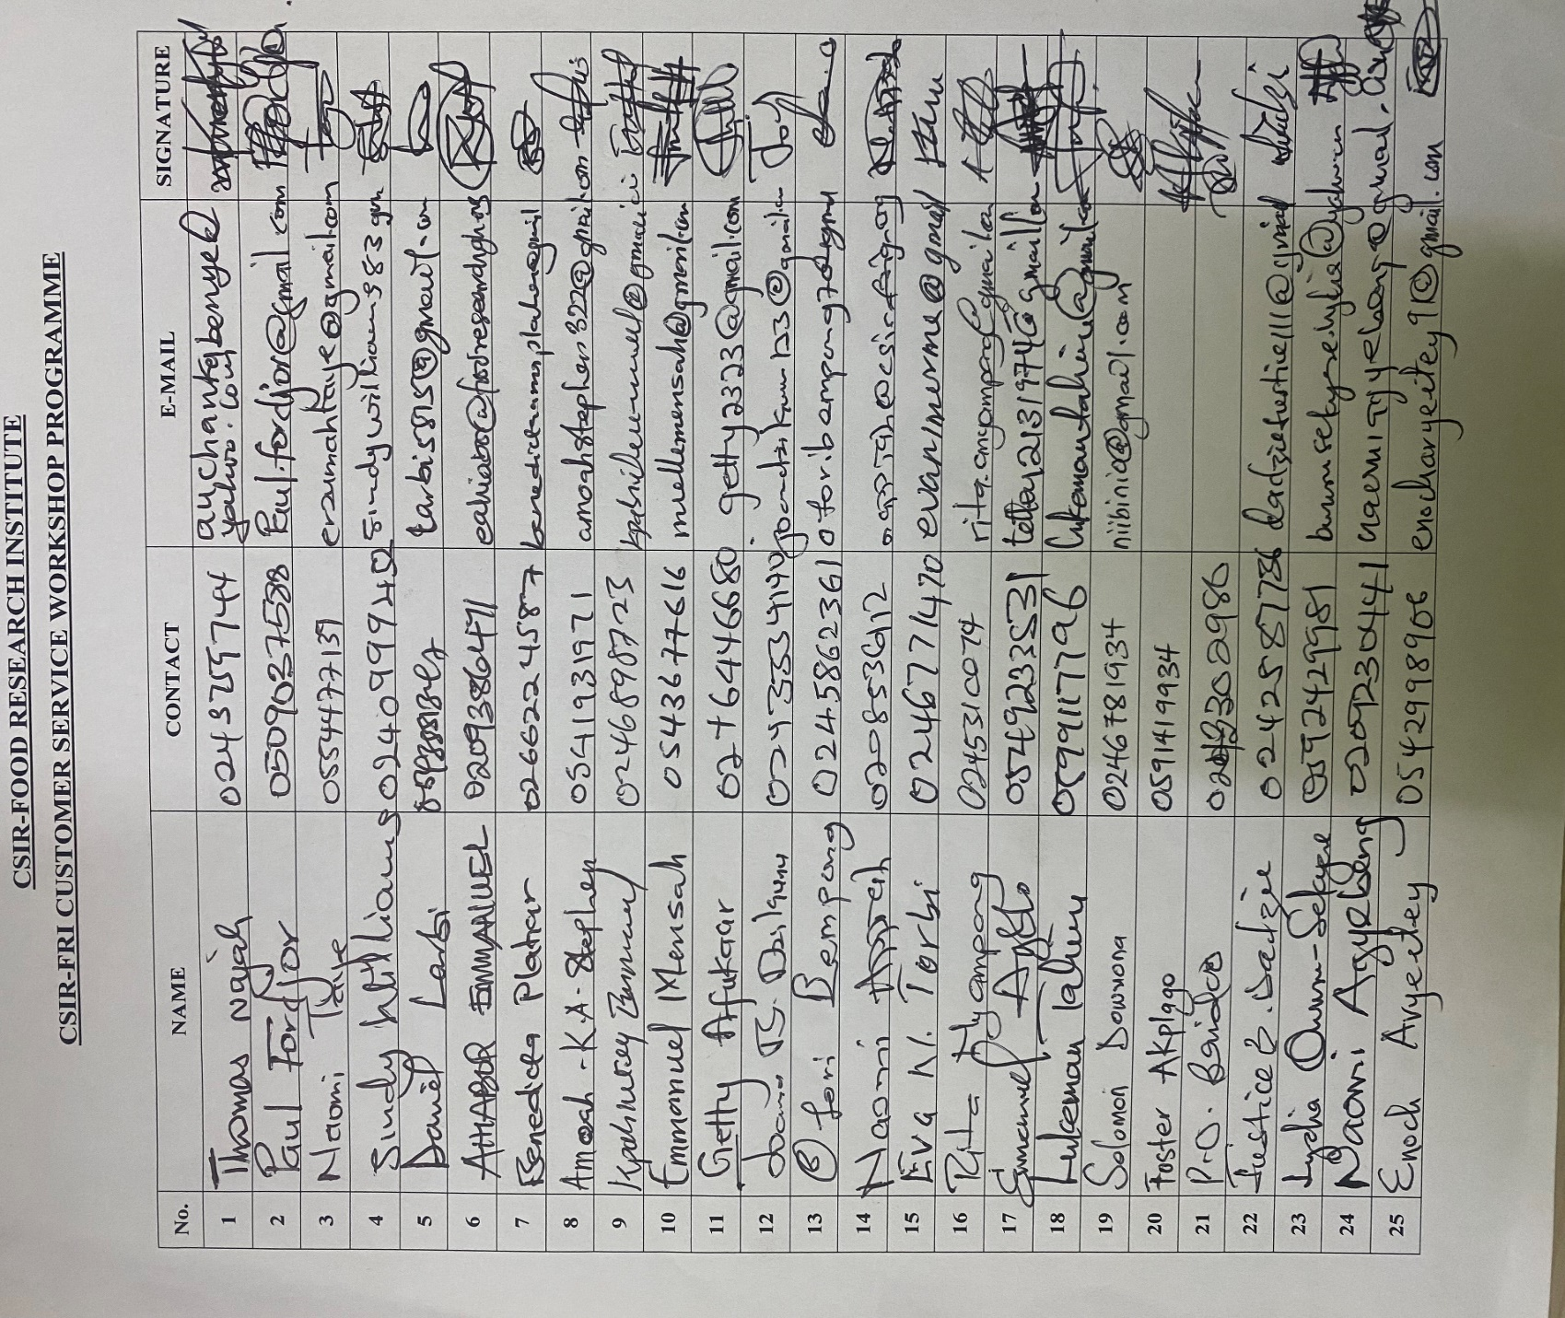

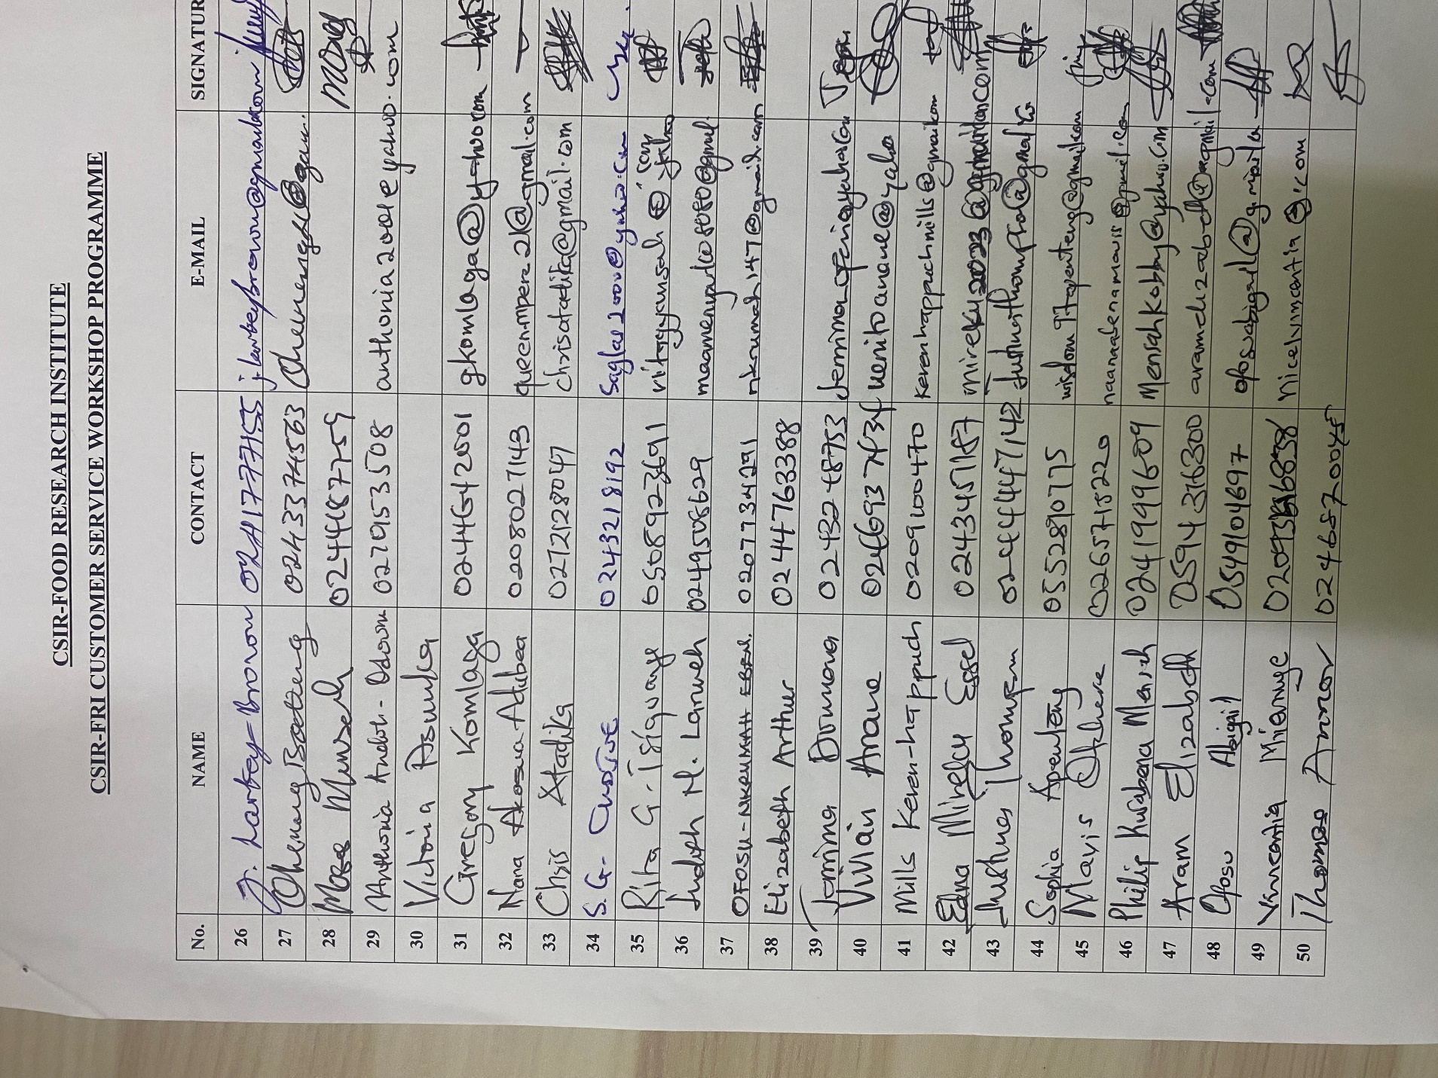

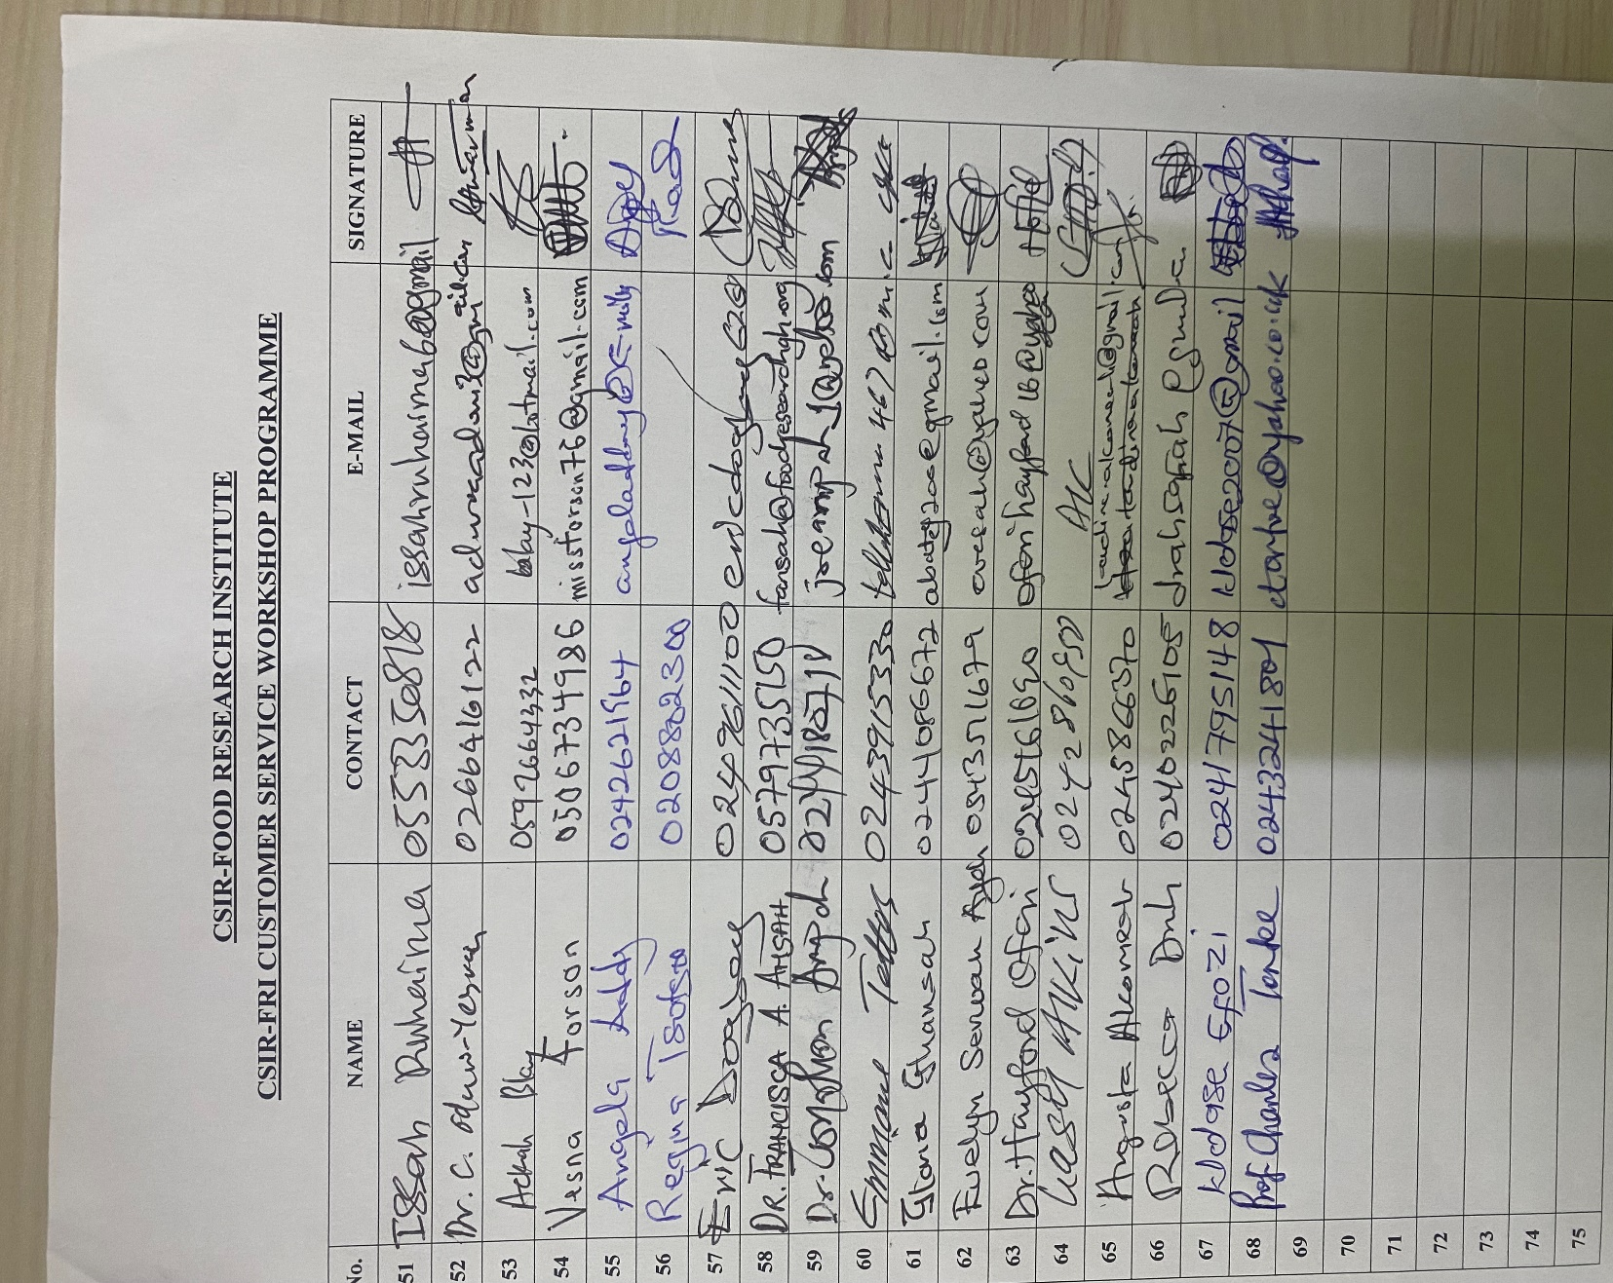

**8.0: Attendants Sheets**